**Exercise: Use the Shirt class**

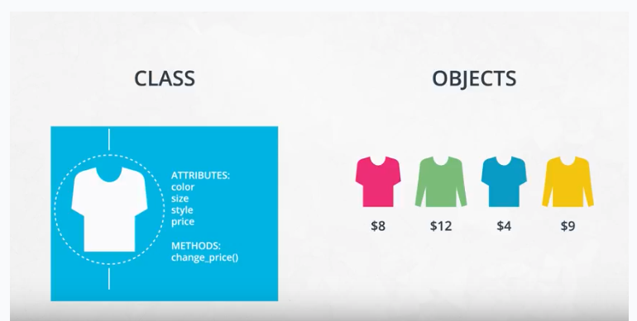

Shirt class exercise

You've seen what a class looks like and how to instantiate an object. Now it's your turn to write code that instantiates a shirt object.

You need to download three files for this exercise. These files are located on this page in the **Supporting materials** section.

* Shirt_exercise.ipynb contains explanations and instructions.
* Answer.py containing solution to the exercise.
* Tests.py tests for checking your code: You can run these tests using the last code cell at the bottom of the notebook.

**Getting started**

Open the Shirt Exercise.ipynb notebook file using Jupyter Notebook and follow the instructions in the notebook to complete the exercise.

**Supporting Materials**

* [Answer](https://video.udacity-data.com/topher/2021/April/60775d13_answer/answer.py)
* [Tests](https://video.udacity-data.com/topher/2021/April/60775d1e_tests/tests.py)
* [Shirt Exercise](https://video.udacity-data.com/topher/2021/April/607760bb_shirt-exercise/shirt-exercise.ipynb)

;